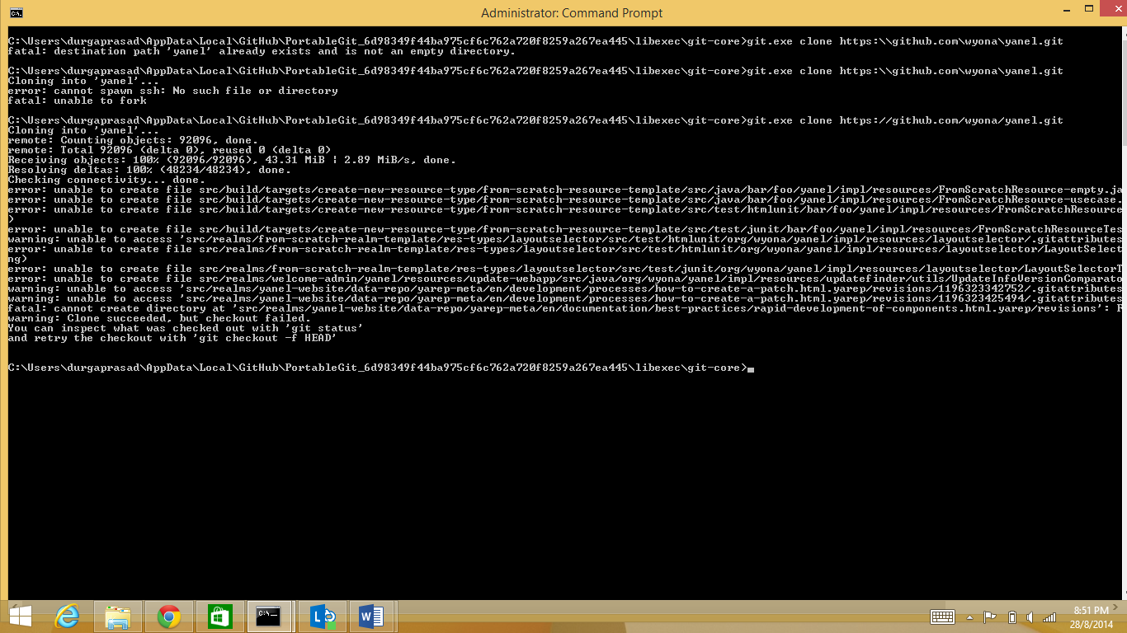

C:\Users\durgaprasad\AppData\Local\GitHub\PortableGit_6d98349f44ba975cf6c762a720f8259a267ea445\libexec\git-core>git.exe clone https:\\github.com\wyona\yanel.git
fatal: destination path 'yanel' already exists and is not an empty directory.

C:\Users\durgaprasad\AppData\Local\GitHub\PortableGit_6d98349f44ba975cf6c762a720f8259a267ea445\libexec\git-core>git.exe clone https:\\github.com\wyona\yanel.git
Cloning into 'yanel'...
error: cannot spawn ssh: No such file or directory
fatal: unable to fork

C:\Users\durgaprasad\AppData\Local\GitHub\PortableGit_6d98349f44ba975cf6c762a720f8259a267ea445\libexec\git-core>git.exe clone https://github.com/wyona/yanel.git
Cloning into 'yanel'...
remote: Counting objects: 92096, done.
remote: Total 92096 (delta 0), reused 0 (delta 0)
Receiving objects: 100% (92096/92096), 43.31 MiB | 2.89 MiB/s, done.
Resolving deltas: 100% (48234/48234), done.
Checking connectivity... done.
error: unable to create file src/build/targets/create-new-resource-type/from-scratch-resource-template/src/java/bar/foo/yanel/impl/resources/FromScratchResource-empty.java (Filename too long)
error: unable to create file src/build/targets/create-new-resource-type/from-scratch-resource-template/src/java/bar/foo/yanel/impl/resources/FromScratchResource-usecase.java (Filename too long)
error: unable to create file src/build/targets/create-new-resource-type/from-scratch-resource-template/src/test/htmlunit/bar/foo/yanel/impl/resources/FromScratchResourceWebTest.java (Filename too long
)
error: unable to create file src/build/targets/create-new-resource-type/from-scratch-resource-template/src/test/junit/bar/foo/yanel/impl/resources/FromScratchResourceTest.java (Filename too long)
warning: unable to access 'src/realms/from-scratch-realm-template/res-types/layoutselector/src/test/htmlunit/org/wyona/yanel/impl/resources/layoutselector/.gitattributes': Filename too long
error: unable to create file src/realms/from-scratch-realm-template/res-types/layoutselector/src/test/htmlunit/org/wyona/yanel/impl/resources/layoutselector/LayoutSelectorWebTest.java (Filename too lo
ng)
error: unable to create file src/realms/from-scratch-realm-template/res-types/layoutselector/src/test/junit/org/wyona/yanel/impl/resources/layoutselector/LayoutSelectorTest.java (Filename too long)
error: unable to create file src/realms/welcome-admin/yanel/resources/update-webapp/src/java/org/wyona/yanel/impl/resources/updatefinder/utils/UpdateInfoVersionComparator.java (Filename too long)
warning: unable to access 'src/realms/yanel-website/data-repo/yarep-meta/en/development/processes/how-to-create-a-patch.html.yarep/revisions/1196323342752/.gitattributes': Filename too long
warning: unable to access 'src/realms/yanel-website/data-repo/yarep-meta/en/development/processes/how-to-create-a-patch.html.yarep/revisions/1196323425494/.gitattributes': Filename too long
fatal: cannot create directory at 'src/realms/yanel-website/data-repo/yarep-meta/en/documentation/best-practices/rapid-development-of-components.html.yarep/revisions': Filename too long
warning: Clone succeeded, but checkout failed.
You can inspect what was checked out with 'git status'
and retry the checkout with 'git checkout -f HEAD'

C:\Users\durgaprasad\AppData\Local\GitHub\PortableGit_6d98349f44ba975cf6c762a720f8259a267ea445\libexec\git-core>

